COMPUTER SCIENCE– NEW (083)

PRACTICAL FILE

2020-2021



NAME: Ujjwal Sharma

CLASS: 12

SECTION: S1

ROLL NO: 40

**INDEX**

|  |  |  |  |
| --- | --- | --- | --- |
| NO. | AIM | PAGE NO. | SIGN |
| 1) | Determine whether a number is a perfect number, an Armstrong number or a palindrome. |  | **Done** |
| 2) | Input a number and check if the number is a prime or composite number. |  | **Done** |
| 3) | Display the terms of a Fibonacci series. |  | **Done** |
| 4) | Compute the greatest common divisor and least common multiple of two integers. |  | **Done** |
| 5) | Count and display the number of vowels, consonants, uppercase, lowercase characters in string. |  | **Done** |
| 6) | Input a string and determine whether it is a palindrome or not; convert the case of characters in a string. |  | **Done** |
| 7) | Write a program for binary search. |  | **Done** |
| 8) | Write a program to generate random numbers between 1 to 6 and check whether a user won a lottery or not. |  | **Done** |
| 9) | Write a program to create a library in python and import it in a program. |  | **Done** |
| 10) | Write a program for linear search. |  | **Done** |
| 11) | Write a program for bubble sort. |  | **Done** |
| 12) | Input a list/tuple of elements, search for a given element in the list/tuple. |  | **Done** |
| 13) | Input a list of numbers and test if a number is equal to the sum of the cubes of its digits. Find the smallest and largest such number from the given list of numbers. |  | **Done** |
| 14) | Write a program to input five students name and their total marks in first semester. Find the highest mark and the name of the student. |  | **Done** |
| 15) | Write a program to create a list by entering countries and respective capital and population. The program should accept the name of a country as an input and print the corresponding capital name and population as output. Otherwise, the program should print an appropriate message if the country is not found in the list. Also, display the details of the list in descending order. |  | **Done** |
| 16) | Write a program using function called insertionSort(Num) to arrange a list of integer elements in ascending order using insertion sort technique. Here, the list is Num. |  | **Done** |
| 17) | WAP to create a matrix with m number of rows and n number of columns. Display the elements in a matrix format.  Note: The number of rows and columns will be decided at runtime of the program. |  | **Done** |
| 18) | WAP to enter any number and display it in words.  Ex 123 - One Two Three |  | **Done** |
| 19) | Create a dictionary with the roll number, name and marks of n students in a class and display the names of students who have marks above 75. |  | **Done** |
| 20) | WAP to take the number of students as input, then ask marks for five subjects as English, Physics, Chemistry, Maths and Computer. If the total marks for any student are less than 200, then print he failed or else print passed.  Use the dictionary to store the student name as key and marks as value. |  | **Done** |
| 21) | WAP to input employee number and name for ‘N’ employees and display all information in ascending order of their employee number. |  | **Done** |
| 22) | WAP to create a dictionary called Census with country name and population. Using two functions, perform the following:  Search_Country() – Enter the country name and displays its respective population.  Delete_Country() – Enter the country name and delete its respective population. |  | **Done** |
| 23) | Given a dual Tuple list, the task is to write a python program to convert second element to negative magnitude of each tuple and first element to positive magnitude of each tuple.  **Input :** test_list = [(3, -1), (-4, -3), (1, 3), (-2, 5), (-4, 2), (-9, -3)]  **Output :** [(3, -1), (4, -3), (1, -3), (2, -5), (4, -2), (9, -3)] |  | **Done** |
| 24) | Write a Python program to check whether an element exists within a tuple. |  | **Done** |
| 25) | Write a Python program to compute the sum of all the elements of each tuple stored inside a list of tuples.  Original list of tuples: [(1, 2), (2, 3), (3, 4)]  Sum of all the elements of each tuple stored inside the said list of tuples: [3, 5, 7] |  | **Done** |
| 26) | Read a text file line by line and display each word separated by a #. Read a text file and display the number of vowels/ consonants/ uppercase/ lowercase characters in the file. |  | **Done** |
| 27) | Create a binary file with name and roll number. Search for a given roll number and display the name, if not found display appropriate message. |  | **Done** |
| 28) | Create a binary file with roll number, name and marks. Input a roll number and update the marks. |  | **Done** |
| 29) | Remove all the lines that contain the character `a' in a file and write it to another file. |  | **Done** |
| 30) | Write a python program to search and display the record of the student from a binary file “Student.dat” containing students records (Rollno, Name and Marks). The user will enter roll number of the student to be searched. |  | **Done** |
| 31) | WAP using function merge(file1,file2) to merge two files and obtain a third file called “NEW.DAT”. The file1 and file2 are two files, which are pass as arguments. Also, display the content of third file. |  | **Done** |
| 32) | Write a menu driven program where you are getting product related details in a file product.txt. menu options are  1. Add Details  2. Search Details  3. Show Details  4. Exit |  | **Done** |
| 33) | WAP to delete the file(s), which you want, should no longer exist in your computer. The file name should be entered at the time of program execution. If the entered file name not exist, display a proper message on screen. |  | **Done** |
| 34) | A file emp.dat contains data attributes like : ecode, name and salary.  Give function definitions to do the following  a) Write the data of an employee.  b) Read the employee data and display all the objects on the screen where salary is between 20000 and 30000. |  | **Done** |
| 35) | Write a menu driven program to add and manipulate data from customer.csv file. Give function to do the following:   1. Add Customer Details 2. Search Customer Details 3. Remove Customer Details 4. Display all the Customer Details 5. Exit |  | **Done** |
| 36) | Write a program to create a queue called Doctor to perform the basic operations on queue using list. The list contains two data fields: Docid and Docname. Write the following functions:  InsertDoc() – To push the data values into the list Docinfo  DeleteDoc() – To remove the data value from the list Docinfo  ShowDoc(): - To display data value for all Docinfo. |  | **Done** |
| 37) | Write two functions queins() to insert and quedel() to delete elements  for customeer information, i.e. custno, cname using list. |  | **Done** |
| 38) | Write a program to create a stack called Product to perform the basic operations on stack using list. The list contains two data fields: ProductId and ProductName. Write the following functions:  InsertProd() – To push the data values into the list Docinfo  DeleteProd() – To remove the data value from the list Docinfo  ShowProd(): - To display data value for all Docinfo. |  | **Done** |
| 39) | Write a menu-based program to perform the operation on queue in python. |  | **Done** |
| 40) | Creating and manipulating database and table structure in SQL – Create, Alter, Drop, Show and Describe.   1. Display all the available databases available in SQL. 2. Create database office and open it. 3. Display all the available tables of Office database. 4. Create a table Emp with following fields. Use appropriate constraints.   Empno, Empname, Desig, Hiredate, Salary, Deptno   1. Add Mobile and Email field in table. 2. Remove Mobile field from the table. 3. Display the structure of Emp table. 4. Remove the Emp table structure and recreate it. |  | **Done** |
| 41) | Inserting, projecting and manipulating records – Insert, Select, Update, Delete   1. Add 10 records in Emp table. 2. Display all the records of Emp table. 3. Increase all the salary of emp by 500. 4. Delete all the employee details working in department no 50. |  | **Done** |
| 42) | **Queries using DISTINCT, BETWEEN, IN, LIKE, IS NULL, ORDER BY, GROUP BY, HAVING**   1. Display the number of departments. Each department should be displayed once. 2. Find the name and salary of those employees whose salary is between 35000 and 40000. 3. Find the name of those employees who live in guwahati, surat or jaipur city. 4. Display the name of those employees whose name starts with ‘M’. 5. List the name of employees not assigned to any department. 6. Display the list of employees in descending order of employee code. 7. Find the average salary at each department. 8. Find maximum salary of each department and display the name of that department which has maximum salary more than 39000. |  | **Done** |
| 43) | **Queries for Aggregate functions- SUM( ), AVG( ), MIN( ), MAX( ), COUNT( )**   1. Find the average salary of the employees in employee table. 2. Find the minimum salary of a female employee in EMPLOYEE table. 3. Find the maximum salary of a male employee in EMPLOYEE table. 4. Find the total salary of those employees who work in Guwahati city. |  | **Done** |
| 44) | Queries for Joining Tables – Cartesian join & Equi join |  | **Done** |
| 45) | Write a program to connect Python with MySQL using database connectivity and perform the following operations on data in database: Fetch, Update and delete the data. |  | **Done** |

CODE AND ANSWERS:



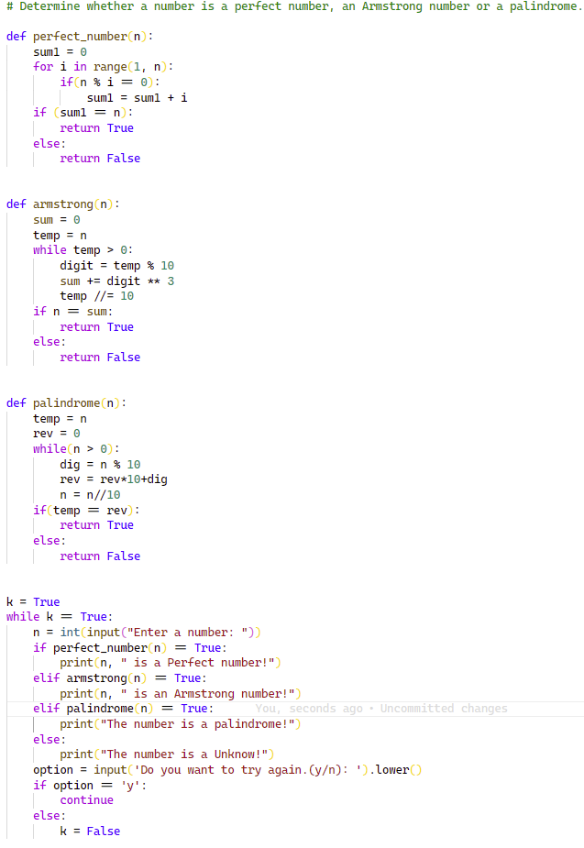

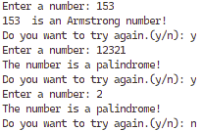



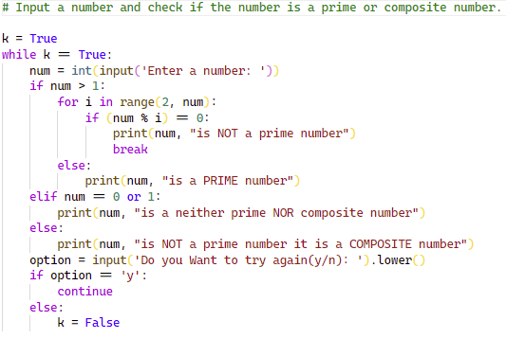

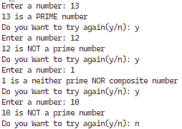



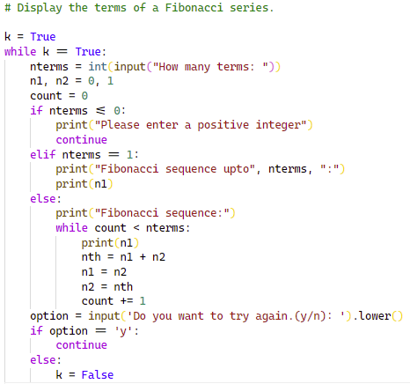

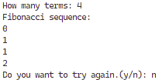



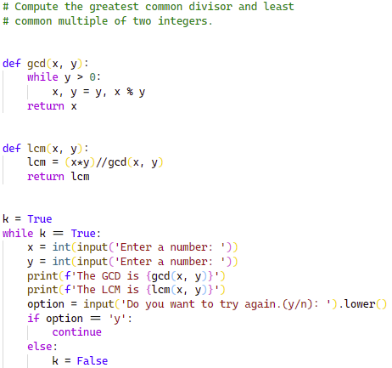

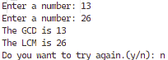



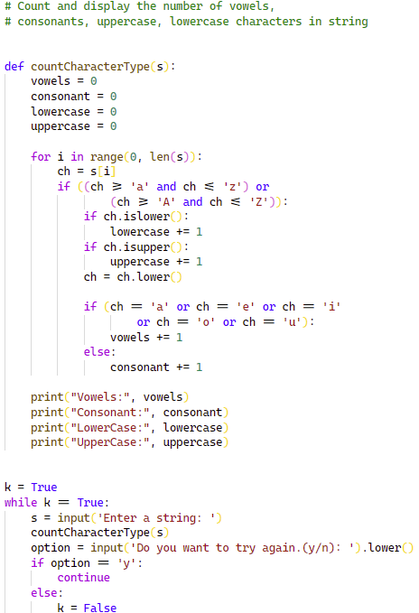

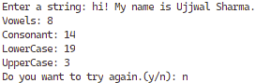



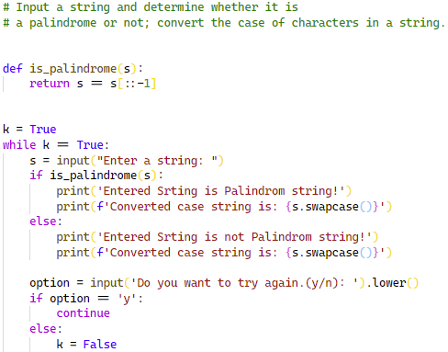  
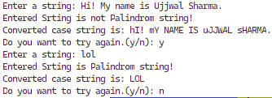



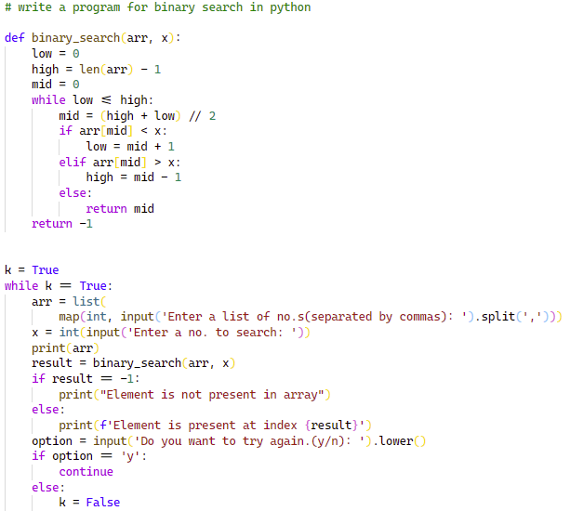

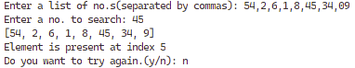



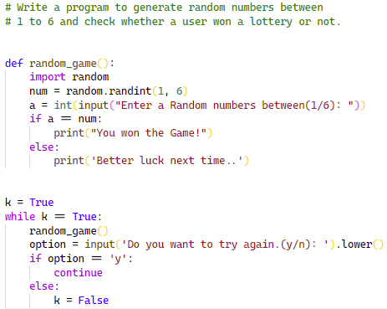

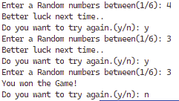



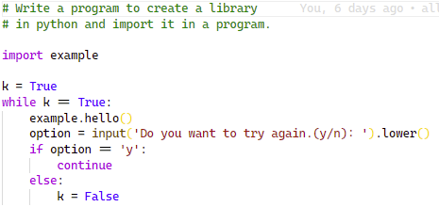







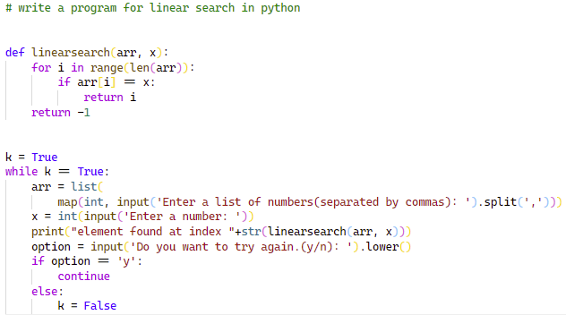





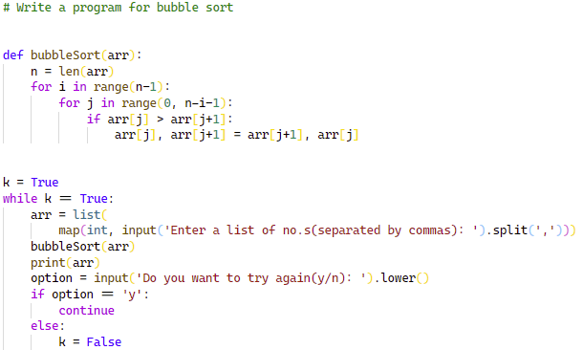





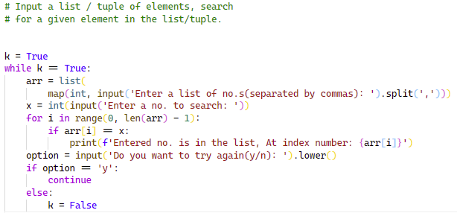





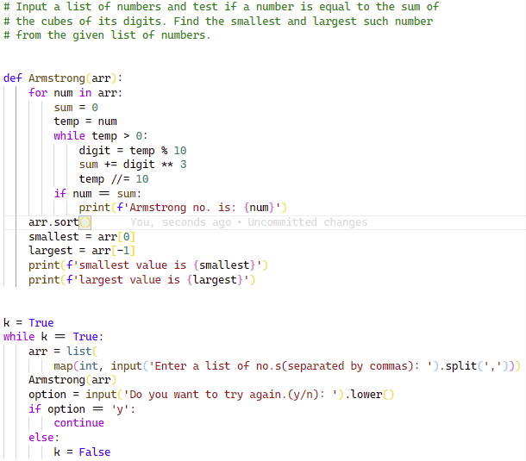

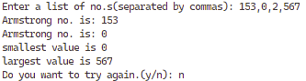



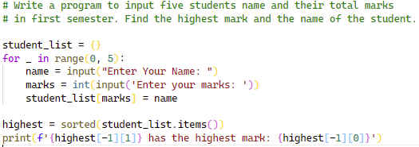

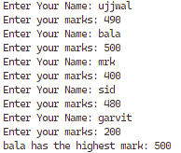



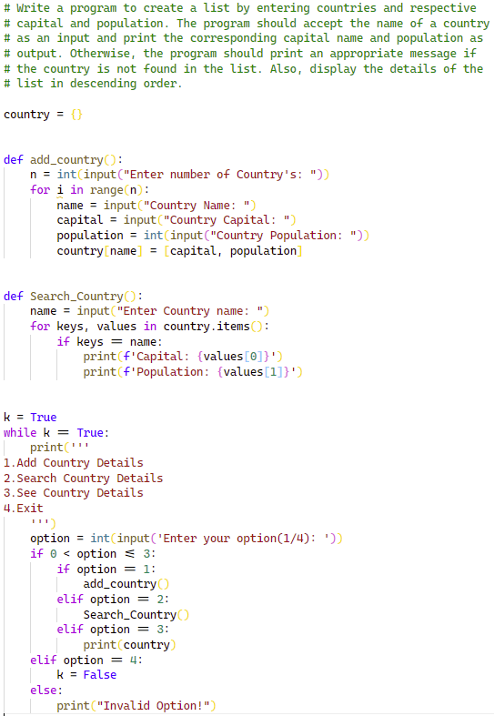

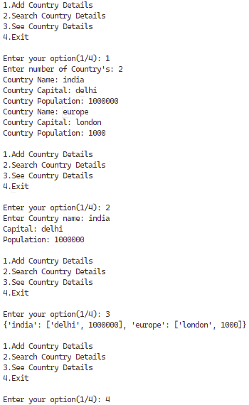



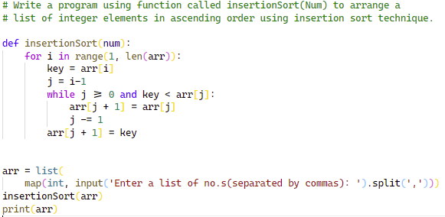





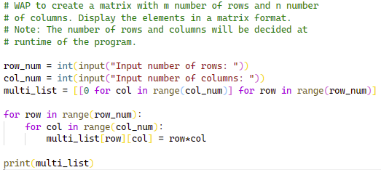





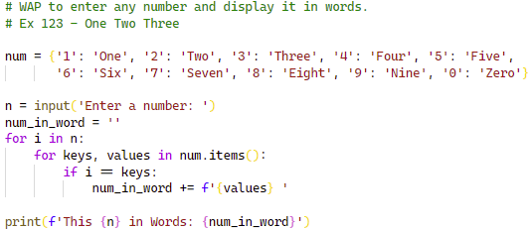





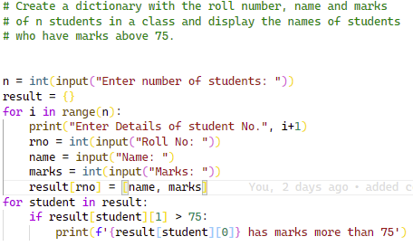

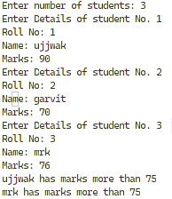



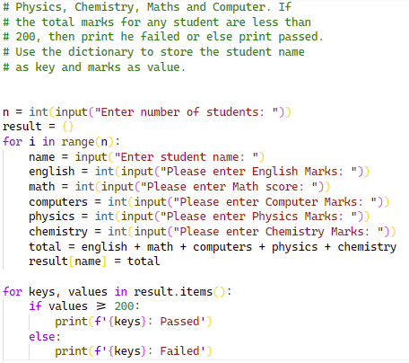

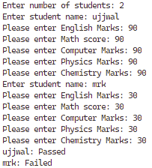



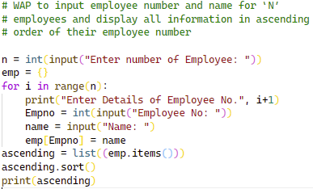

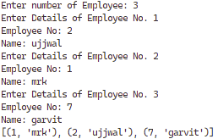



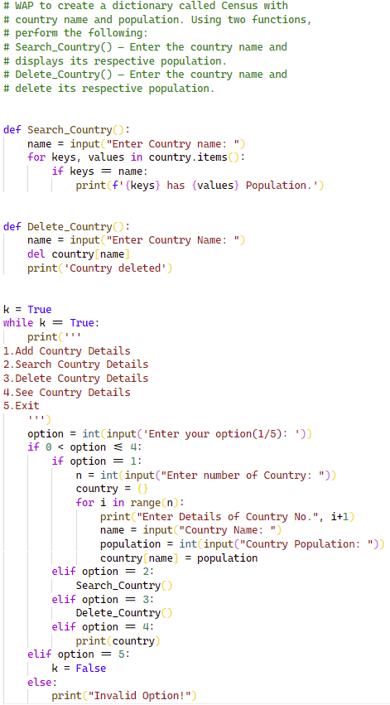

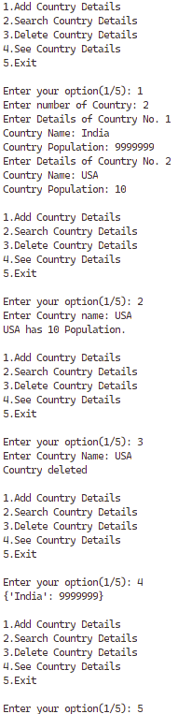



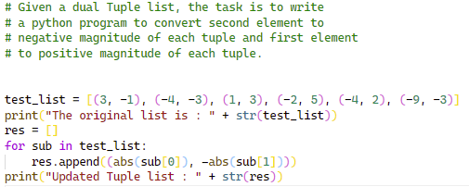





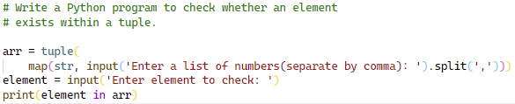





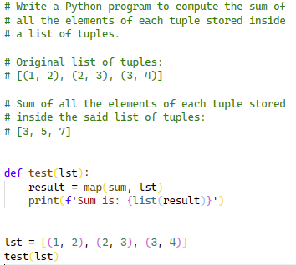





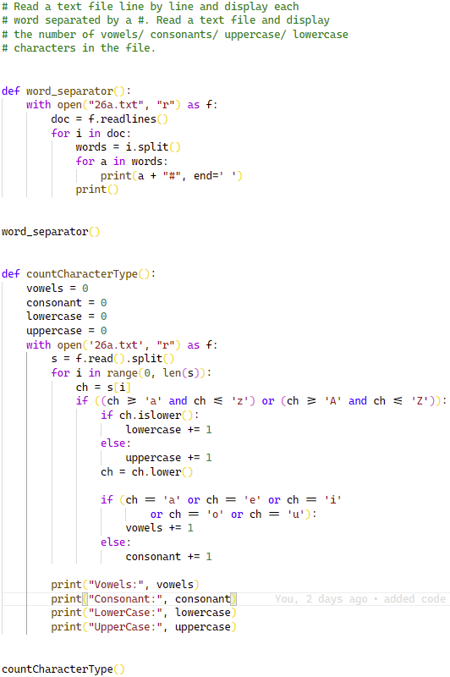

TEXT FILE (26A.TXT)

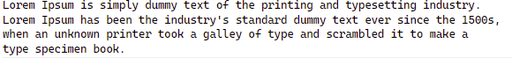

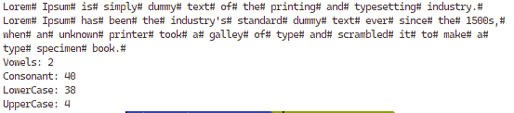



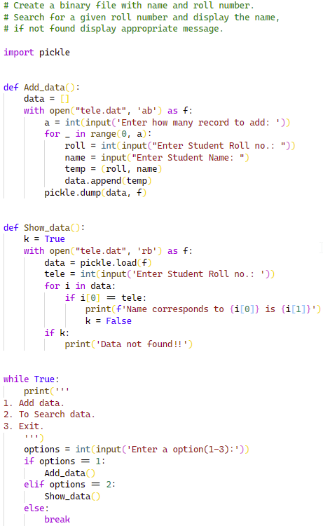

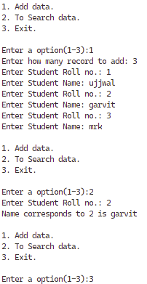



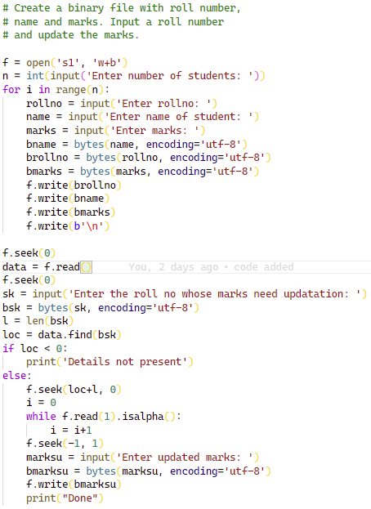

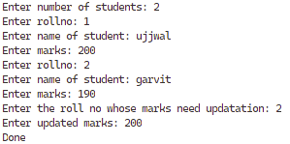



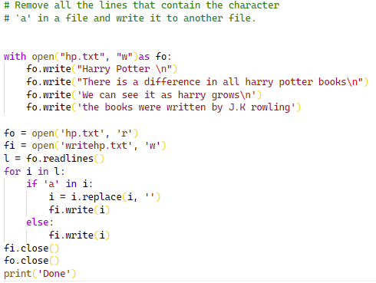



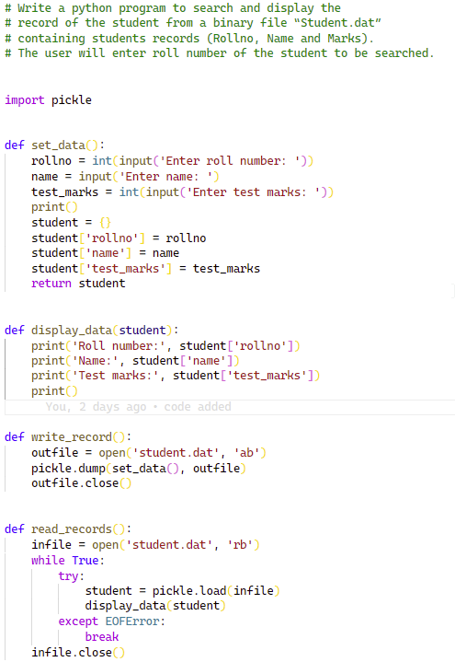

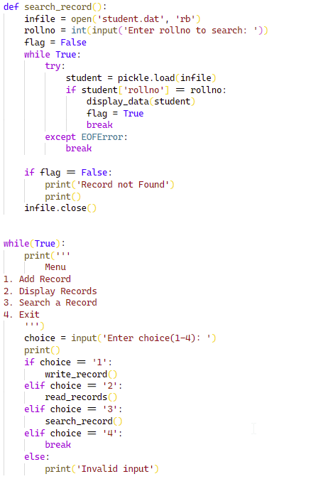

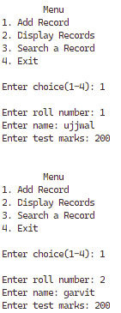

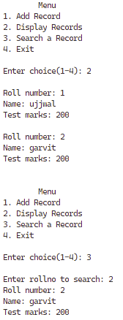



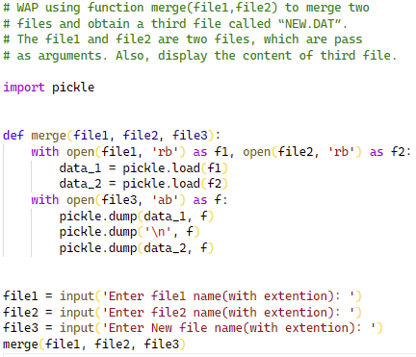





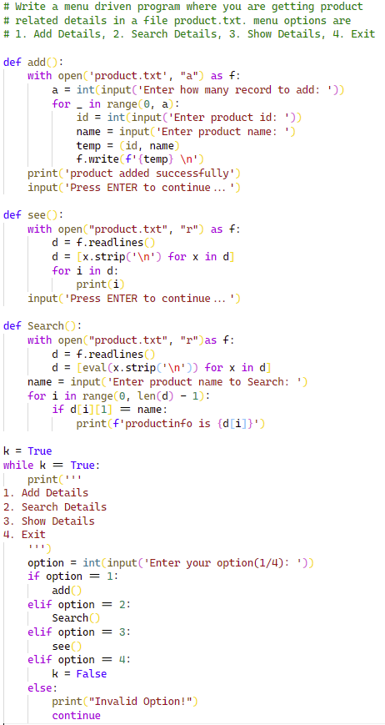

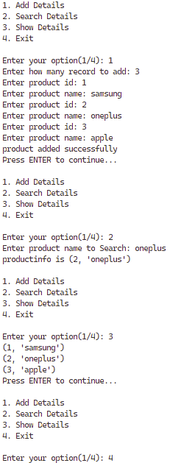



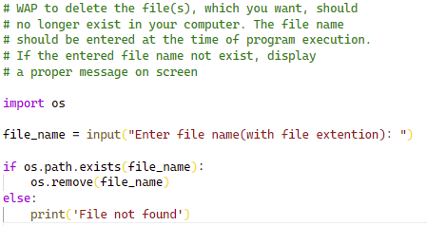



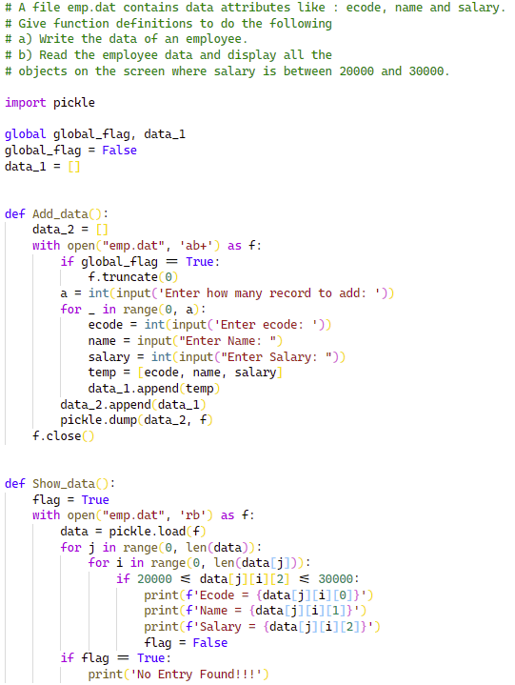

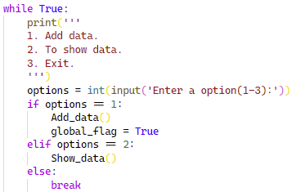

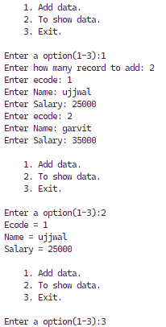



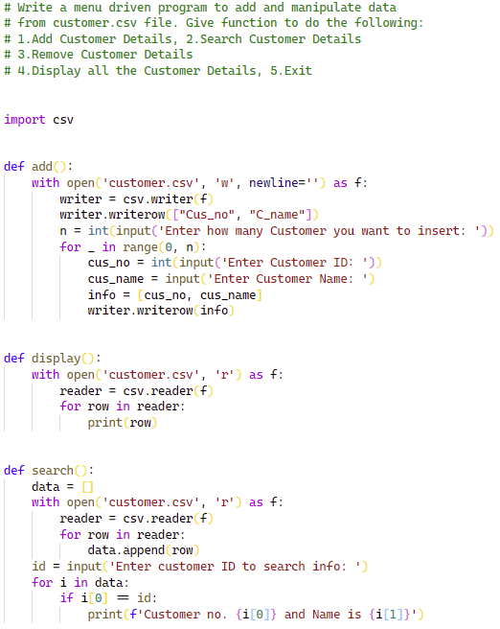

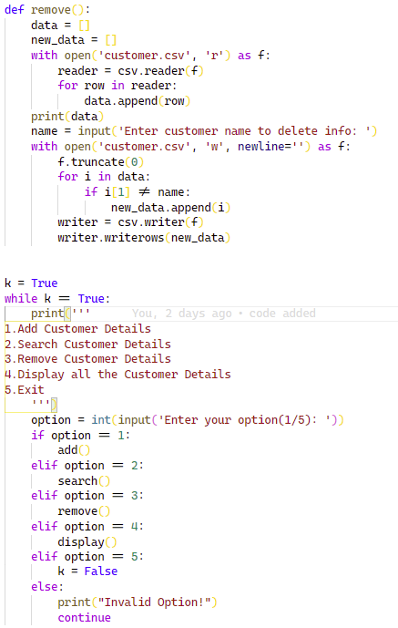

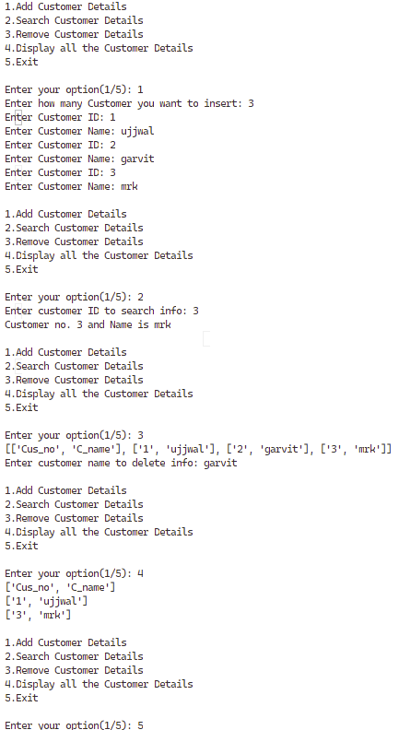



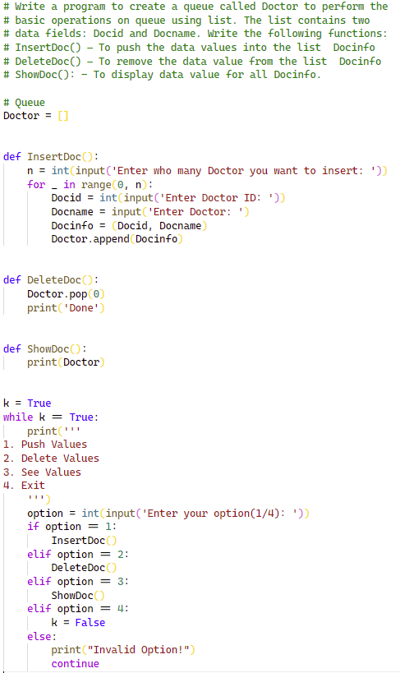

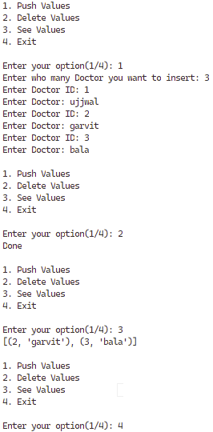



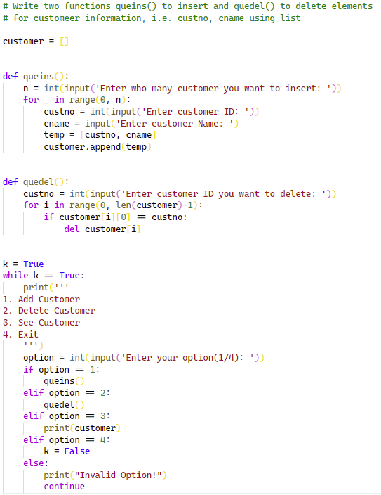

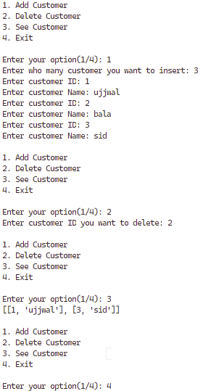



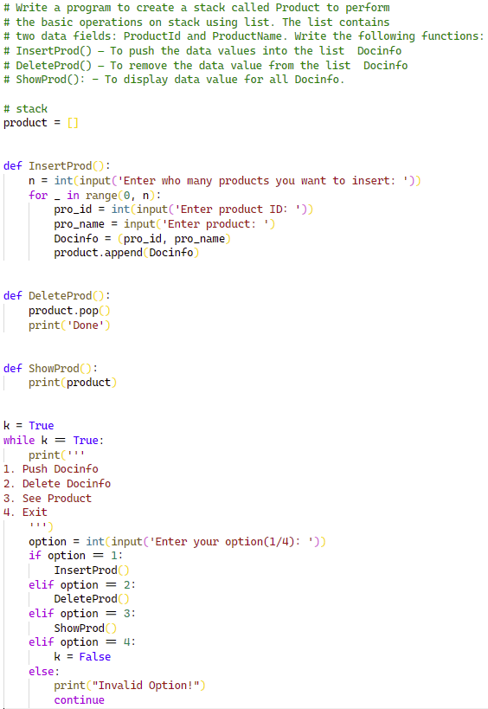

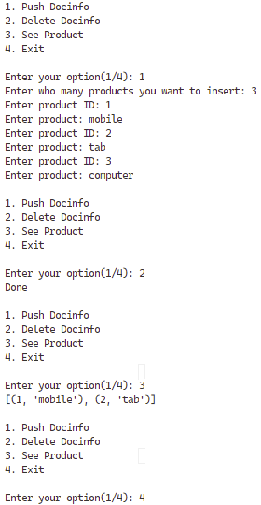



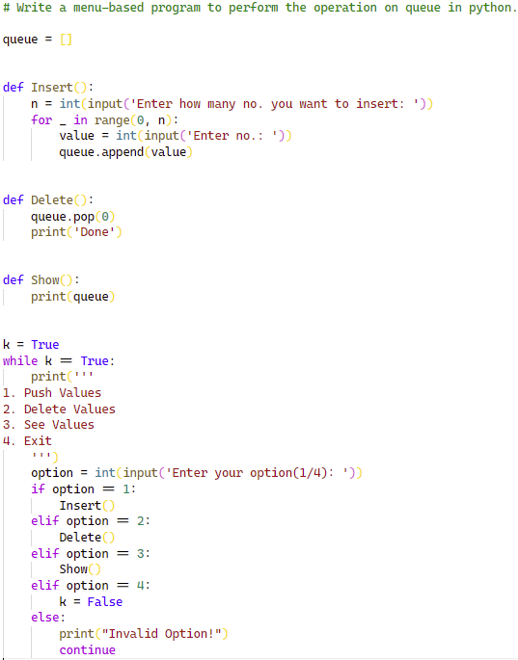

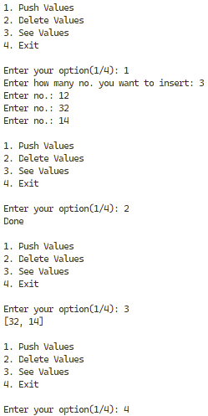

2. SHOW DATABASES;
3. CREATE DATABASE office.
4. SHOW TABLES;
5. CREATE TABLE emp(

Empno int,

Empname varchar(30),

Desig varchar(30),

Hiredate date,

Salary int,

Deptno int)

1. ALTER TABLE emp ADD Mobile int, email varchar(50);
2. ALTER TABLE emp DROP COLUMN Mobile;
3. DESC emp;
4. DROP office.emp;

insert into employee(emp_id, emmp_name, age, phone_num, dept_id)

values(1,"ujjwal",18,1305240266,1),

values(2,"garvit",13,1125723767,1),

values(3,"mrk",24,0708474991,1),

values(4,"harsh",15,2377720050,1),

values(5,"muskan",13,0370602270,1),

values(6,"amrit",15,6051842944,1),

values(7,"sukarn",14,3411679960,1),

values(8,"shailaja",18,8698480510,1),

values(9,"akshay",17,0467788858,1),

values(10,"kashish",16,0467788858,1);

1. SELECT *FROM emp_table;
2. UPDATE emp_table SET salary = salary + 50;
3. DELETE FROM emp_table WHERE department_no = 50;
5. SELECT DISTINCT department FROM Employee;
6. SELECT Emp_name, Salary FROM Employee WHERE Salary BETWEEN 35000 AND 40000;
7. SELECT Emp_name FROM Employee WHERE city = 'Guwahati' or city = 'Surat' or city = 'Jaipur';
8. SELECT Emp_name FROM Employee WHERE Emp_name LIKE 'M%';
9. SELECT Emp_name FROM Employee WHERE department IS NULL;
10. SELECT * FROM employees ORDER BY emp_id ASC;
11. SELECT department, AVG(salary) FROM employees GROUP BY department;
12. NOT DONE

a. SELECT avg(salary) FROM employees;

b. SELECT MIN(salary) FROM employees;

c. SELECT MAX(salary) FROM employees;

d. SELECT SUM(salary) FROM employees WHERE city = 'Guwahati';



CARTESIAN JOIN:

Syntax:

SELECT table1.column1 , table1.column2, table2.column1...

FROM table1

CROSS JOIN table2;

table1: First table.

table2: Second table

EQUI JOIN:

Syntax:

SELECT column_list

FROM table1, table2....

WHERE table1.column_name =

table2.column_name;



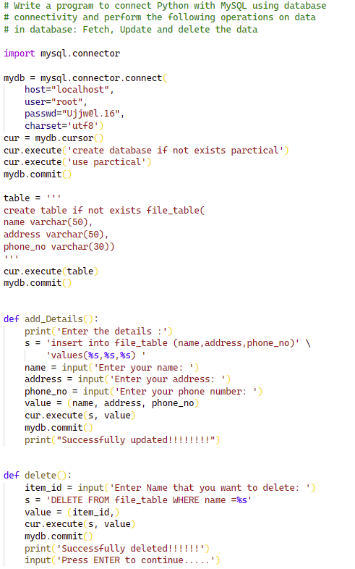

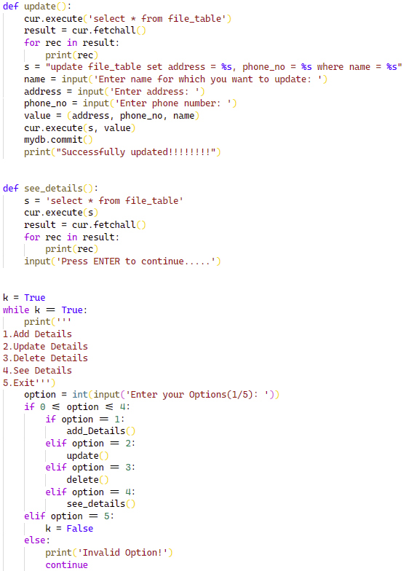

s

